Express does lot of the configuration for us, letting us focus on the business logic rather than server logic.

* Starting Server:

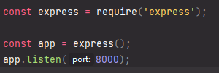

**Middle-ware:** We can add bunch of middlewares in express. It takes a callback function (req, res, next) which will be executed for every request.

We have to call next() after the middleware work done otherwise next middlewares won’t be executed.

**Routes:** The use() function also takes a optional first parameter, path. Here we can define the path we want to match as a string/regex/path-pattern etc.